Simple Chatbot
Manish Basnet
University of the Cumberlands

Introduction
This project extends the complex-dialog sample from Microsoft's BotBuilder-Samples repository into a bot that meets three specific functional requirements: responding to multiple prompts, listing its own capabilities on request, and handling input that falls outside its scope. The sample was chosen over a simpler option like EchoBot because it already implements a multi-step, stateful conversation (collecting a user's name, age, and review preferences across nested dialogs), which gave the extension work something realistic to interact with rather than a trivial echo loop. This report documents the lifecycle followed, the specific code changes made and why, what the process revealed about how the framework operates internally, the challenges encountered, and the mitigations chosen.
Environment and Running the Baseline
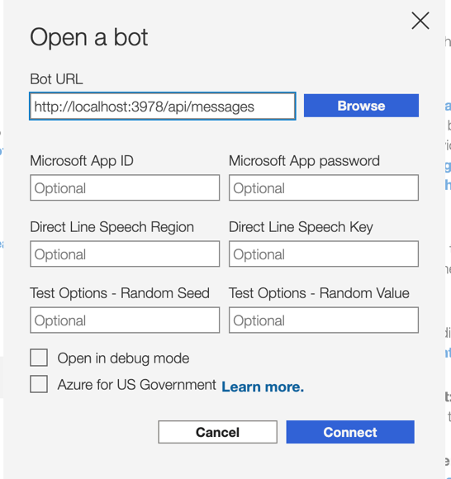
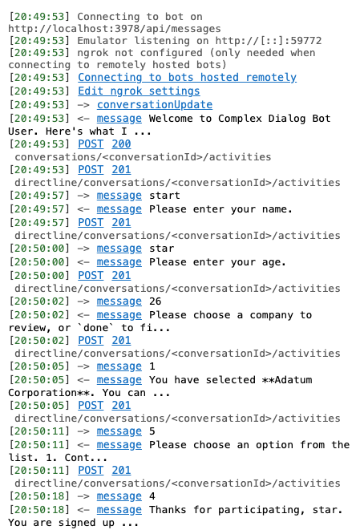
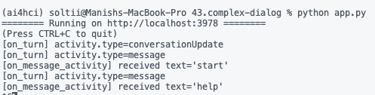
No new environment was created specifically for this assignment. The conda environment used had already been created in a previous assignment, with the common Python libraries pre-installed. This environment runs Python 3.11.15. The sample was installed (pip install -r requirements.txt) and run (python app.py) directly against the existing setup. No version-related errors occurred at any point. The bot started, served /api/messages, and held full conversations correctly. The 3.8.2 constraint, at least for this sample and this set of dependency versions, was not load-bearing.
Understanding the Bot Before Changing It
Before writing any code, I traced the existing behavior using the Emulator's raw JSON activity log and temporary print() statements placed at successive points in the call chain.
Reading the JSON first establishes the shape of what the bot sends and receives. Every activity carries a type (almost always "message" for normal turns, "conversationUpdate" when a user joins), a from/recipient pair identifying sender and receiver, a conversation.id, text, a timestamp, and a serviceUrl the bot would use to call back into the channel. Outgoing bot messages also include a replyToId that links them to the triggering user message.
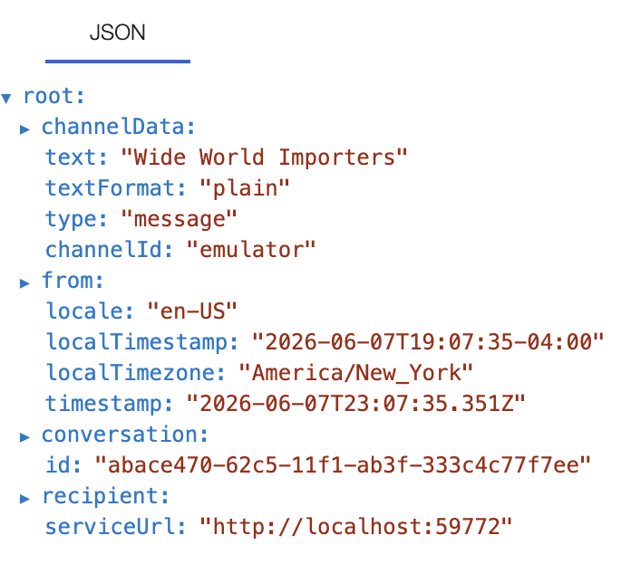
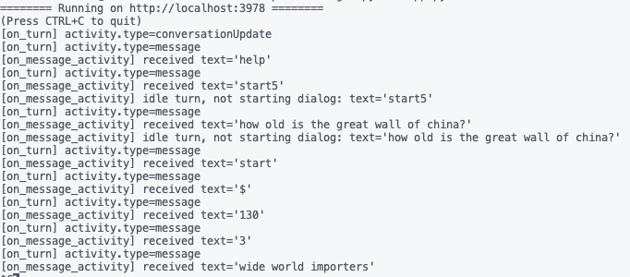
From there, the same single message was traced through the source by adding prints at four points: the messages() HTTP handler in app.py, DialogBot.on_turn (printing activity.type), DialogBot.on_message_activity (printing the activity text), and inside DialogHelper.run_dialog (printing dialog_context.active_dialog.id before and after continue_dialog()). Watching that last value change across a conversation from None, to "WFDialog", to "TopLevelDialog", to "ReviewSelectionDialog", and back was the single most clarifying observation in the whole project
Implementing the Capabilities-Listing Feature
The central design question was where to intercept a message like "help" so that it works regardless of which step the active waterfall dialog is waiting on, without corrupting that dialog's saved state. Turns out, this is called a "dialog interruption" pattern: checking for global commands in the activity handler, before the message is routed into `DialogHelper.run_dialog`, and returning early when one matches, so `DialogState` is never touched and whatever prompt the user was mid-way through answering (e.g., "Please enter your age") remains exactly where it was.
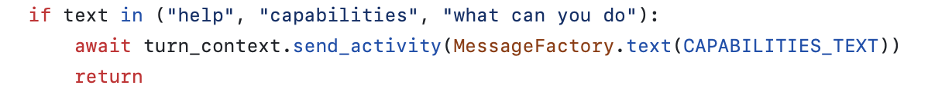
A related decision was to match trigger phrases by exact comparison rather than a substring search. The bot's first prompt asks the user to type their name, and a trigger word like "help" could plausibly appear inside a real name or answer; substring matching would risk a false positive that derails the conversation. Comparing the full, normalized strip().lower() message against a small set of known phrases avoids that collision while staying simple to reason about.

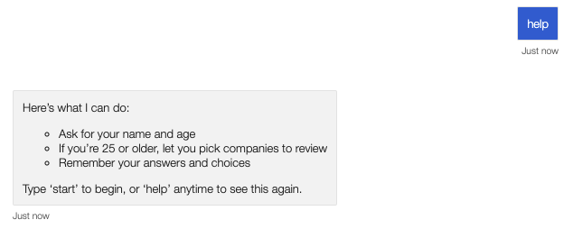
Testing also showed that the original sample starts the name/age dialog whenever any text is typed while idle, which would swallow an out-of-scope question (e.g., "How old is the Great Wall of China?") as if it were the first answer in a new conversation. To resolve this, `DialogHelper.run_dialog` was extended with a `should_begin` flag so the bot only starts the dialog from idle on an explicit command (`start`, `restart`, `begin`); any other idle input is instead checked against a small heuristic for "does this look like a question" (ends in `?`, starts with a question word) and answered with either an "I can't answer that" message plus the capabilities list, or a generic nudge toward `start`/`help`. This heuristic is intentionally lightweight rather than a true intent classifier; building one would require an external NLU/LLM service, which would be a noticeably greater effort.
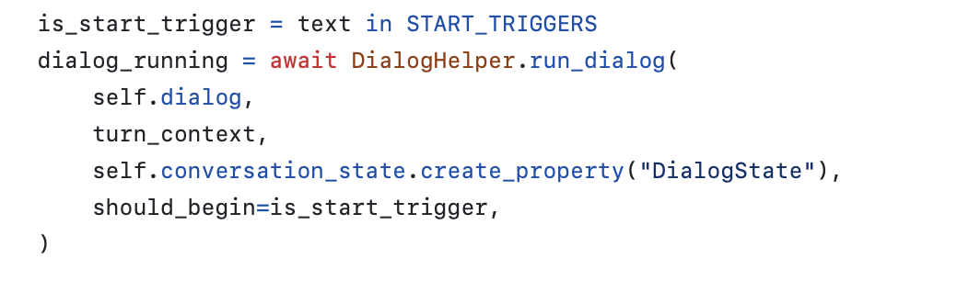
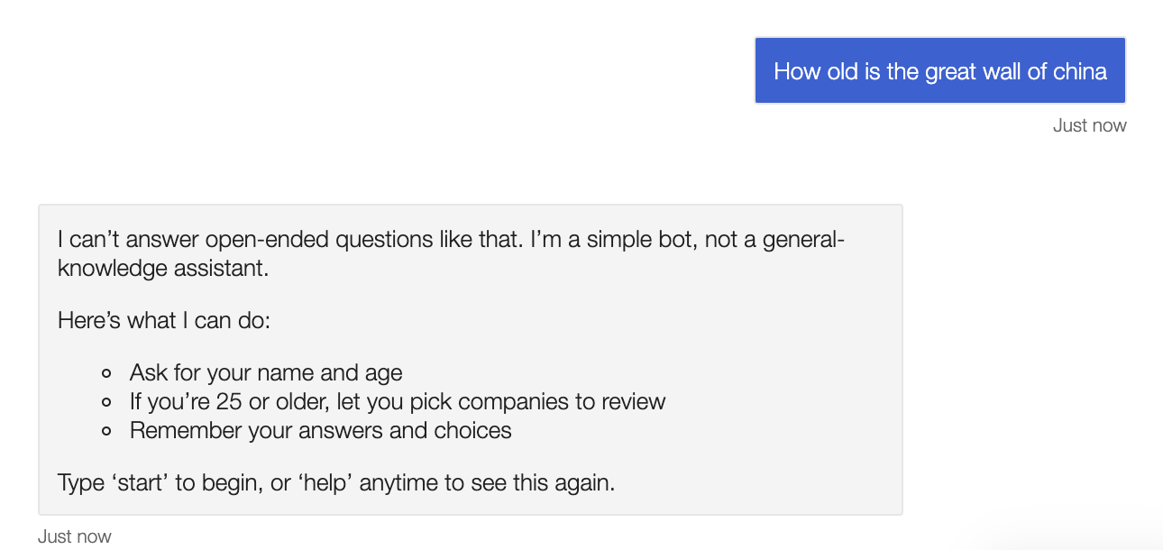

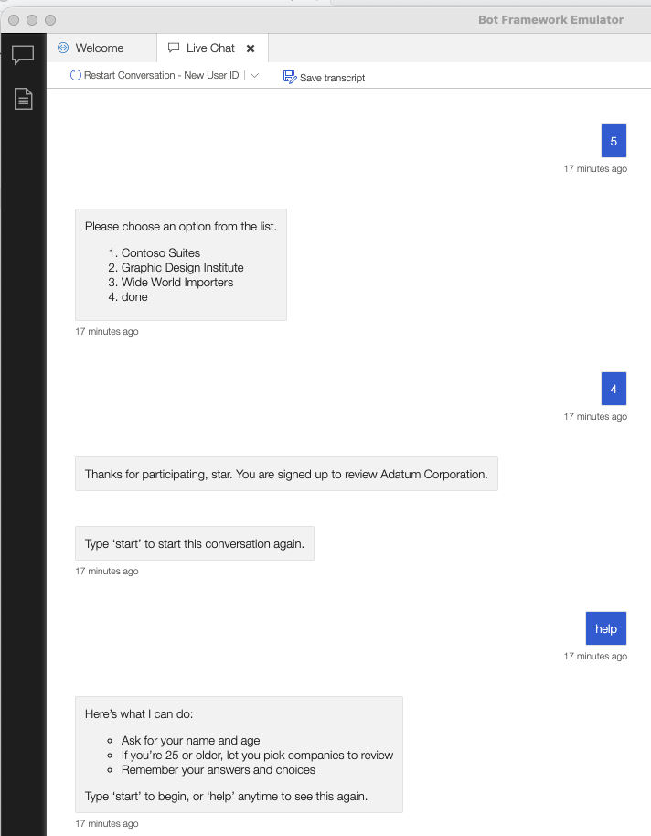
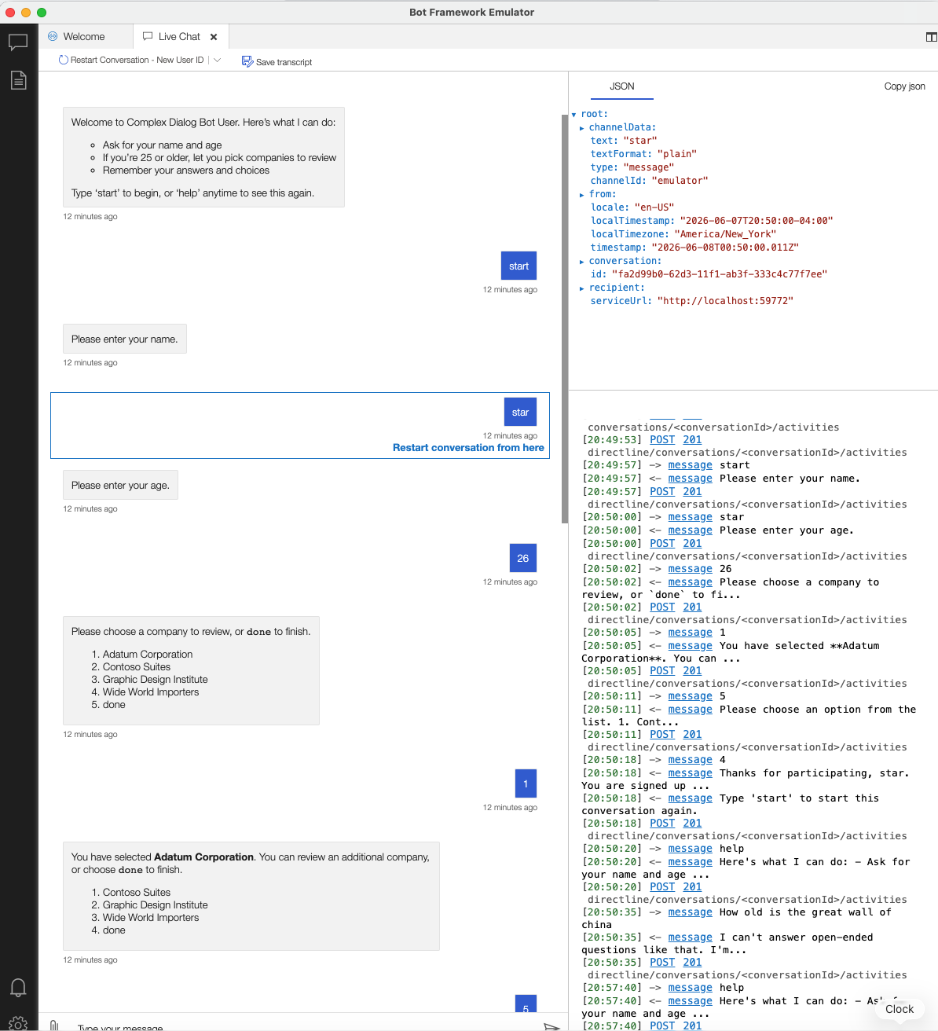
Learnings
Working through this assignment and, in particular, deliberately tracing JSON activity logs into running code produced a sequence of concrete realizations that a beginner to bot development would not get from the docs alone:
- An "Activity" is just JSON, and a "Turn" is just one HTTP request/response cycle.
- ActivityHandler.on_turn is a dispatcher, not a handler. It routes by activity.type to methods like on_message_activity or on_members_added_activity. Seeing activity.type printed in real time made it clear why a welcome message appears only once per user (triggered by conversationUpdate, not message).
- A multi-step conversation is a literal stack of dialogs, persisted as DialogState and rehydrated each turn by DialogSet/DialogContext. The waterfall steps are not the bot remembering where it is in any magical sense; they are ordinary Python methods resumed in sequence, with step_context.result, carrying forward the prior step's prompt response.
- State storage is per-user and overwritten, not appended. Inspecting MainDialog.final_step revealed that accessor.set(...) replaces the previously stored UserProfile for a user outright, a detail that would matter immediately if this bot were extended to track history across sessions.
Conclusion
The completed bot satisfies the assignment's functional requirements, it handles a multi-step conversation, lists its capabilities both proactively (in its welcome message) and on request ("help"), and responds appropriately to input it cannot process while remaining a small, traceable codebase. The most direct path for extension is replacing the question-detection heuristic with a call to an AI-as-a-service intent classifier (e.g., Azure Cognitive Services / Conversational Language Understanding, or an LLM-based classifier), which the current design isolates behind a single function boundary specifically so that a swap can happen without touching the rest of the bot's turn-handling logic.
AI Disclosure and Project Repository
NotebookLM: Used to highlight the week’s content, learning resources, and assignment requirements
Claude Code: Used to create a learning plan to understand the sample chatbot and how the messages are being handled across different files. Also used to verify and review my changes for correctness.
The report is my sole work, and I accept responsibility for all submitted work.
References
BotBuilder-Samples/samples/python/43.complex-dialog at main · microsoft/BotBuilder-Samples. https://github.com/microsoft/BotBuilder-Samples/tree/main/samples/python/43.complex-dialog
BotFramework-Emulator/README.md at main · microsoft/BotFramework-Emulator. https://github.com/Microsoft/BotFramework-Emulator/blob/main/README.md

